**Project Design Phase-II**

**Data Flow Diagram &User Stories**

|  |  |
| --- | --- |
| **Date** | 07 October 2022 |
| **Team ID** | PNT2022TMID41909 |
| **Project Name** | Signs with Smart Connectivity for Better Road Safety |
| **Maximum Marks** | 2 Marks |

**Data Flow Diagrams:**

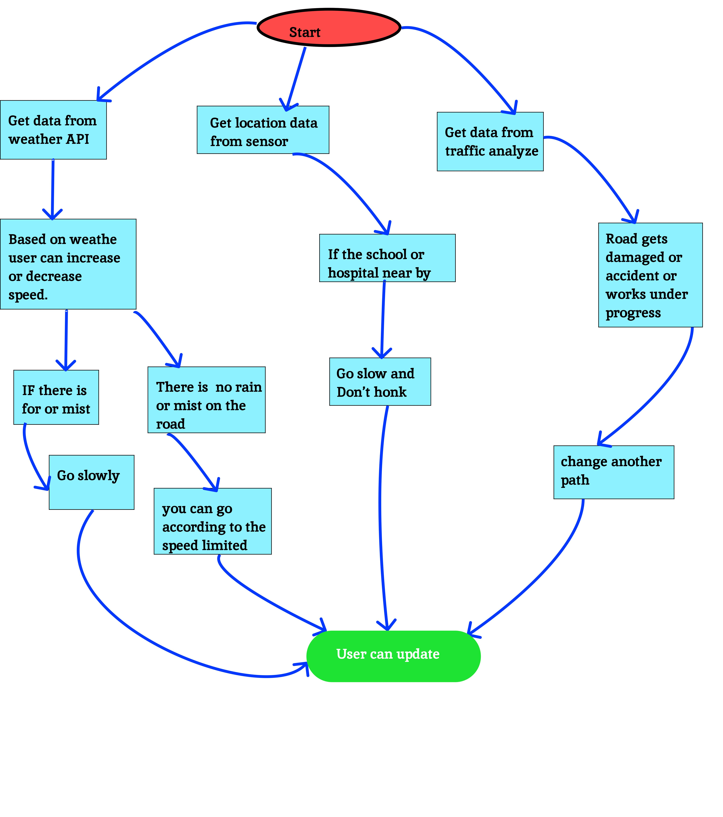

**User Stories**

| **User Type** | **Functional Requirement (Epic)** | **User Story Number** | **User Story / Task** | **Acceptance criteria** | **Priority** |
| --- | --- | --- | --- | --- | --- |
| User 1 | User visibility / Usability | USN-1 | To display the speed limited and sign indicated on smart sign board | Can view the speed limited and sign | High |
| User 2 |  | USN-2 | According to weather conditions user can increase or decrease the speed | Can received the weather app for the user | High |
|  | Interface | USN-3 | As a user the interface or signboard should be simple and easily readable. | Can view the interface easily | Low |
|  | Data | USN-4 | Display the data regarding the weather change and fog or mist. | Weather changes are displayed | Medium |
| Administrator (Officials) | Problem solving / fault clearance | USN-5 | As a officer, can maintain the sign board, speed limited and also school or hospital it through periodic monitoring. | Officer can monitor the sign board for properly functioning day to day life. | High |